 | INDIAN INSTITUTE OF TECHNOLOGY ROORKEE
Programming in C and C++ (CSC-101)

Assignment 4 40 marks

Note : (No function / matrix ]are allowed to be used)
Q-1) Write a C program that prints numbers from 1 to n*n arranged in a clockwise spiral pattern inside an n x n grid, without using any 2D arrays or function calls.

Enter n: 5

1 2 3 4 5 16 17 18 19 6
15 24 25 20 7
14 23 22 21 8
13 12 11 10 9
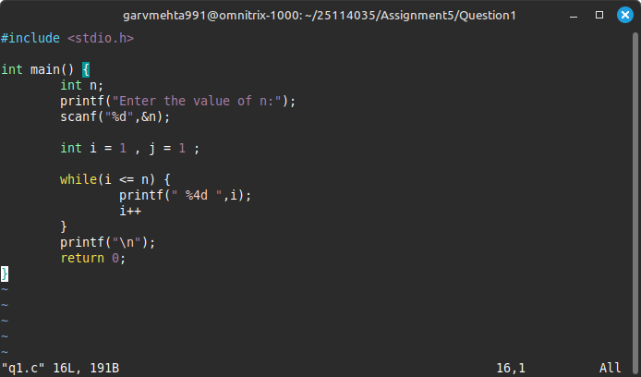

Q-2) Write a C program to print concentric square patterns which use only while loops. It only takes an odd number as input. If the user gives an even number it gives an error.

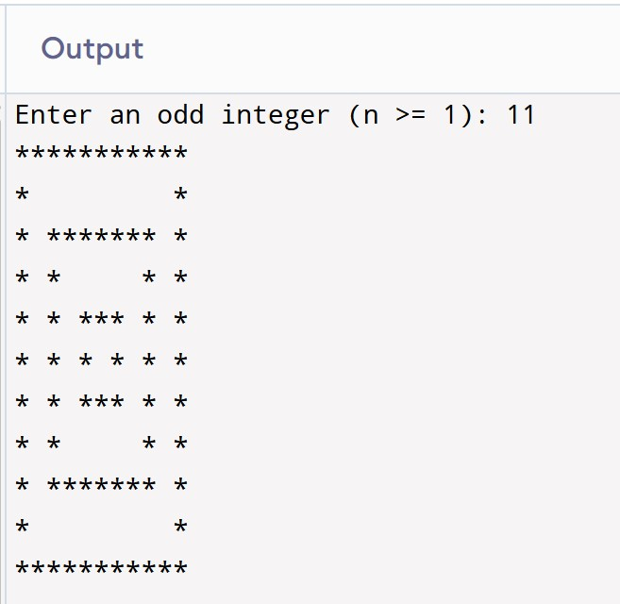
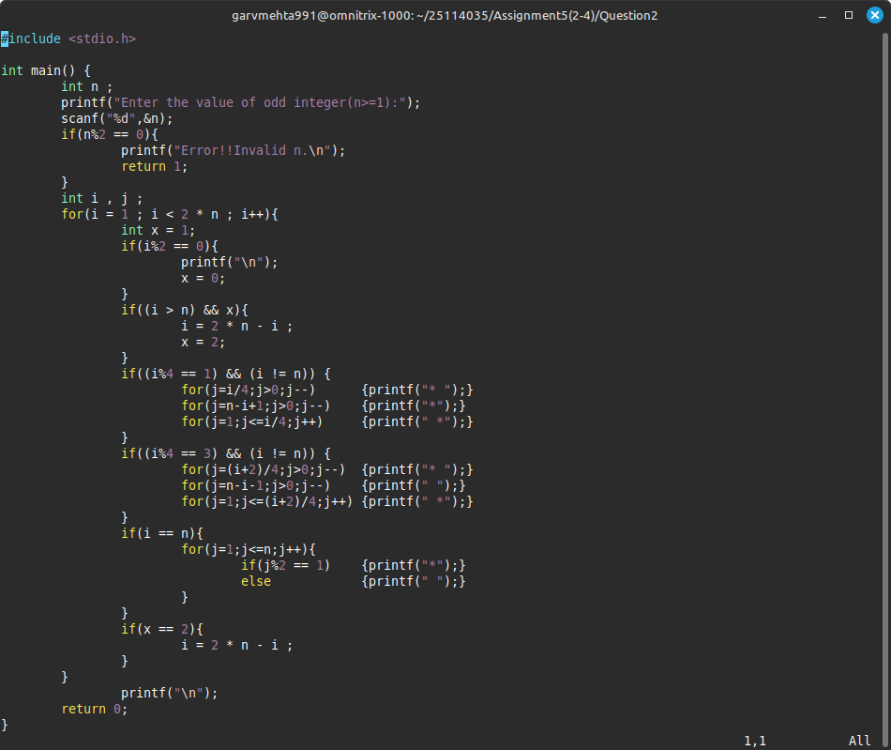

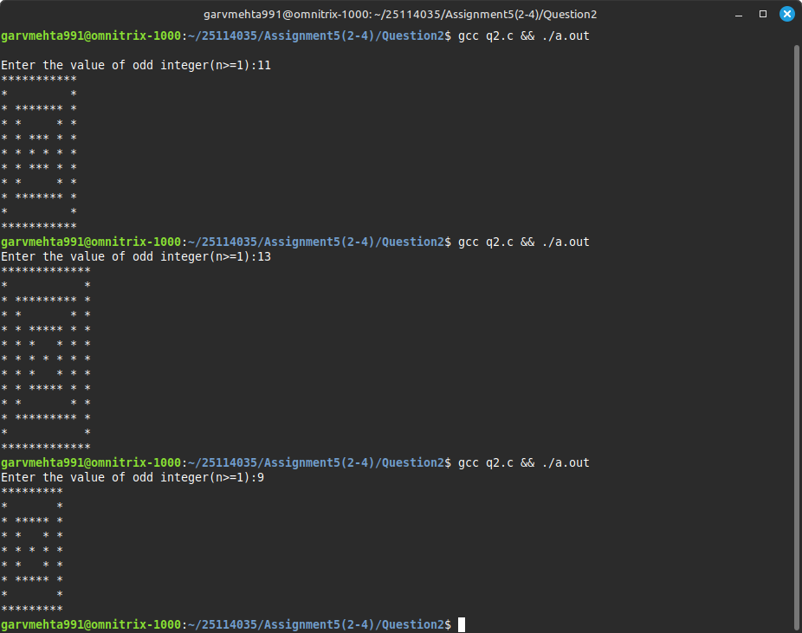

3)Write a C program to find all perfect numbers between 1 and 100,000. A number m is called a perfect number if the sum of all its positive divisors, excluding the number itself, equals m. In other words, if σ(m) = m, where σ(m) is the sum of all positive divisors of m, excluding m itself. For example, σ(12) = 1 + 2 + 3 + 4 + 6 = 16, so 12 is not a perfect number because 16 ̸= 12, 28 is a perfect number because σ(28) = 1 + 2 + 4 + 7 + 14 = 28.

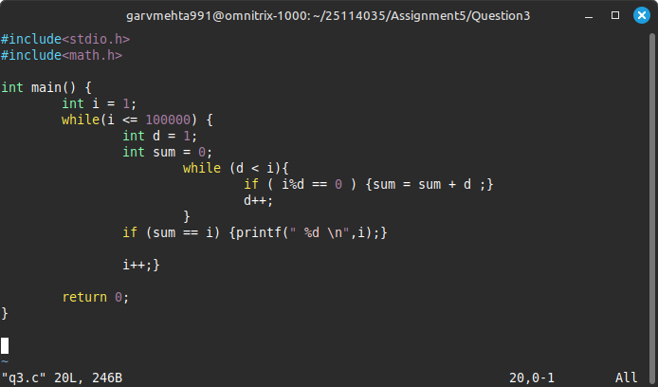

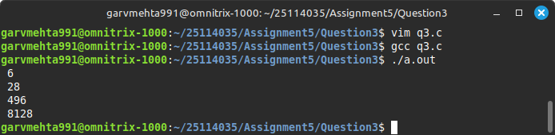

4)Write a C program that performs a sequence of arithmetic operations on integers using a switch statement. Operators can be +, -, *, /, or % and are treated as equal precedence and the expression ends with =. The evaluation happens from left to right. Your program should compute the result, handle division/modulo by zero, and report invalid operators or if the expression is invalid i.e two operator/number consecutive and all possible checking should be done. Use switch for operation control, and include appropriate logic where appropriate.

Output:

Input ending with = :
100 + 20 * 2 / 5 - 10 =

Output:
Result = 18
